Ill Music
“Got a Dream”

Written by Huw Lloyd-Langton

Got a dream I'd like you all to share
It's so clear ain't no clouds up there
Icy streams and sunny bliss
Sweet air no-one should miss
Got a dream I'd like you all to share
People smiling and no brick walls
Nothing there to fear at all

Got a dream I'd like you all to share
It's not unusual it's not unseen is my dream
I'm sure it's one that most all people have seen
There's no money not much to say
Plenty of time to laugh and play

Got a dream I'd like you all to share
There's no taxes and no violent ends
Just time that's fun to spend
Got a dream I'd like you all to share
Got a dream I'd like you all to share
Got a dream I'd like you all to share
Got a dream I'd like you all to share

The service was led by The Reverend William Ridding

All are invited to a reception after the service.

Stalbridge Village Hall
off Lower Street
Dorset
DT10 2NF

8
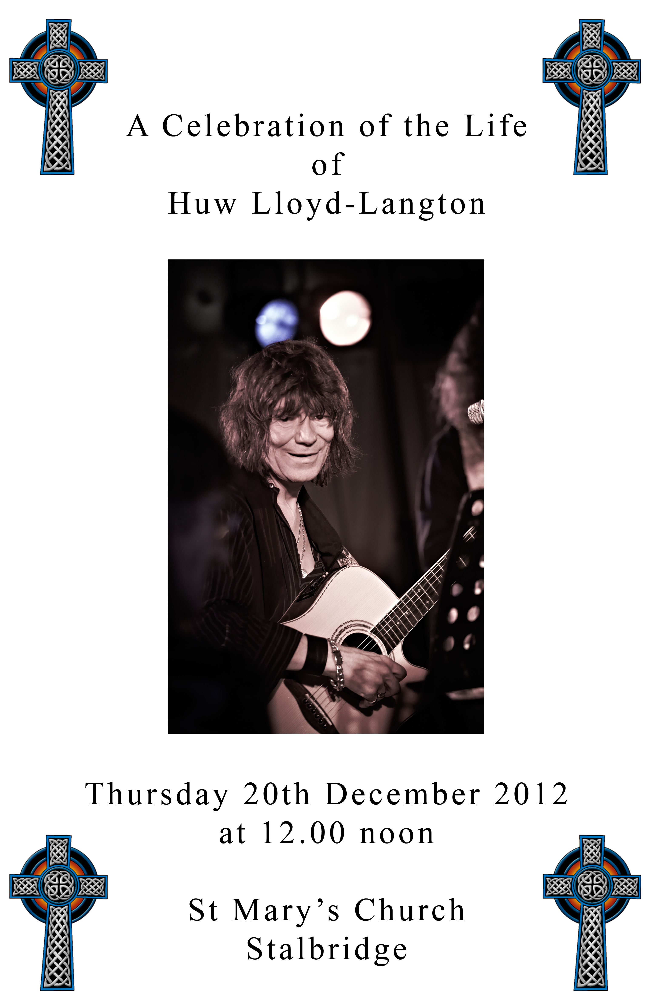
Music

A compilation, including “Farewell”, by Huw Lloyd-Langton

Hymn
“Lord the Light of Your Love (Shine, Jesus, Shine)”

Written by Graham Kendrick

Lord, the light of your love is shining,
in the midst of the darkness, shining;
Jesus, Light of the World, shine upon us,
set us free by the truth you now bring us,
shine on me, shine on me.

Shine, Jesus, shine,
fill this land with the Father’s glory;
blaze, Spirit, blaze,
set our hearts on fire.
Flow, river, flow,
flood the nations with grace and mercy;
send forth your Word, Lord,
and let there be light.

Lord, I come to your awesome presence,
from the shadows into your radiance;
by the blood I may enter your brightness,
search me, try me, consume all my darkness.
Shine on me, shine on me.

As we gaze on your kingly brightness
so our faces display your likeness,
ever changing from glory to glory,
mirrored here may our lives tell your story.
Shine on me, shine on me.

The Sentences of Scripture

Introduction

2
Hymn
“When The Saints Go Marching In”
Performed by Phillip (Dead Fred) Reeves

Oh when the saints go marching in
Oh when the saints go marching in
I want to be in that number
When the saints go marching in

Oh when the band begins to play
Oh when the band begins to play
I want to be in that number
When the band begins to play

~ PIANO SOLO ~

Oh when they play that rock and roll
Oh when they play that rock and roll
I want to be in that number
When they play that rock and roll

Oh when the new world is revealed
Oh when the new world is revealed
How I want to be in that number
When the new world is revealed

Oh when the saints go marching in
Oh when the saints go marching in
I want to be in that number
When the saints go marching in

Commendation and Farewell

The Committal

The Blessing

7
Well it may bring war
Any old thing
Look into your mind's eye
See what you can see

Look into your mind's eye
See what you can see
There's hundreds of people
Like you and me

Oh, hurry on sundown
Hurry on sundown
Oh, hurry on sundown
Hurry on sundown

Prayers
This response is used:
Lord, in your mercy
hear our prayer.
At the end:
God of mercy, entrusting into your hands all that you have made and rejoicing in our communion with all your faithful people, we make our prayers through Jesus Christ our Saviour.
Amen.
The Lord’s Prayer

Our Father, who art in heaven,
hallowed be thy name;
thy kingdom come;
thy will be done,
on earth as it is in heaven.
Give us this day our daily bread.
And forgive us our trespasses,
as we forgive those who trespass against us.
And lead us not into temptation;
but deliver us from evil.
For thine is the kingdom,
the power, and the glory,
for ever and ever.
Amen.
6
The Collect

Scripture Reading

1 Corinthians 13.4-13 Read by Pastor Julian Melfi

Love is patient; love is kind; love is not envious or boastful or arrogant or rude. It does not insist on its own way; it is not irritable or resentful; it does not rejoice in wrongdoing, but rejoices in the truth. It bears all things, believes all things, hopes all things, endures all things.

Love never ends. But as for prophecies, they will come to an end; as for tongues, they will cease; as for knowledge, it will come to an end. For we know only in part, and we prophesy only in part; but when the complete comes, the partial will come to an end.

When I was a child, I spoke like a child, I thought like a child, I reasoned like a child; when I became an adult, I put an end to childish ways. For now we see in a mirror, dimly, but then we will see face to face. Now I know only in part; then I will know fully, even as I have been fully known. And now faith, hope, and love abide, these three; and the greatest of these is love.

Tribute given by Kris Brock

Music
“Dragons and Fables”

Written by Huw Lloyd-Langton
Performed by Dead Fred, Mr Dibs and Richard Chadwick
I am the child of wars never won
Take heed prisoner I am the one
Your battle is over before it's begun
For a child on the run I am free

3
Many tournaments fought in this land
Flying banners now dashed in the sand
The colours you wear will not keep me
For a child on the run I am free

The courts and knights of the table
Bold stories of dragon and fable
Your sword is red-stained I can see
For a child on the run I am free

Silks satins riches in plenty
Acres of land four and twenty
I am not you I am me
For a child on the run I am free

I am the child of wars never won
Take heed prisoner I am the one
Your battle is over before it's begun
For a child on the run I am free

Tribute given by Andrew Briggs and Kirsty Reader

Hymn
“Amazing Grace (My Chains Are Gone)”

Traditional/Chris Tomlin
Performed by Phillip (Dead Fred) Reeves and John Butler

Amazing grace, how sweet the sound
That saved a wretch like me
I once was lost, but now I'm found
Was blind, but now I see

'Twas grace that taught my heart to fear
And grace my fears relieved
How precious did that grace appear
The hour I first believed

My chains are gone
I've been set free

4
My God, my Saviour has ransomed me
And like a flood His mercy rains
Unending love, Amazing grace
The Lord has promised good to me
His word my hope secures
He will my shield and portion be
As long as life endures
[2x]
My chains are gone
I've been set free
My God, my Saviour has ransomed me
And like a flood His mercy rains
Unending love, Amazing grace
The earth shall soon dissolve like snow
The sun forbear to shine
But God, Who called me here below
Will be forever mine
Will be forever mine
You are forever mine

Tribute by Mark Nygate

Short tribute by Dave Brock
Music
“Hurry on Sundown”

Written and performed by Dave Brock

Well hurry on sundown
See what tomorrow brings
Hurry on sundown
See what tomorrow brings
Well it may bring war
Any old thing
Look into your mind's eye
See what you can see

5

